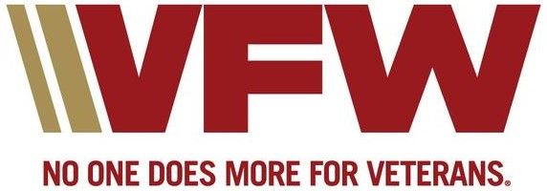
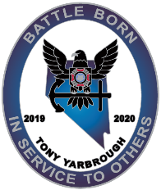
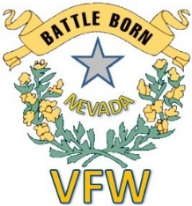

WEBSITE SPONSORING AGREEMENT
VETERANS OF FOREIGN WARS DEPARTMENT OF NEVADA
This agreement is between the VFW Department of Nevada and the Sponsoring company with the description of the service that will be provided on WWW.VFWNV.COM website. Such service will follow our social media policy that is provided on our website. Any content not deemed compliant with said policy may be removed by the Department Webmaster. The Sponsoring company may make changes to the content to make it compliant, discuss the issue with the Department Webmaster, or request an appeal by our review committee.
VFWNV.COM will place the sponsor’s fixed-sized logo (minimum 400x400 pixels) in a rotating banner placed on our main page that contains the sponsor’s link to their webpage on our site. The sponsor will be provided a logon to their webpage exclusive of VFWNV.COM to make changes to their webpage at-will. All changes to the webpage must remain consistent with the original authorized sponsorship conditions unless approved in advance by the Department Webmaster. The Sponsor’s logo must be provided in .jpg or .png [preferred] format to the Department Webmaster at webmaster@vfwnv.com.
Website security will randomly and sporadically scan for any malicious activity such as viruses, malware, etc., and if the sponsors webpage is found to be infected it will be removed without delay and the sponsor informed. Any violation of this agreement will result in removal of Sponsor’s webpage until corrected and verified without any renumeration for any unposted lost time.
VFWNV.COM assumes no responsibility for Sponsors content or any result of user’s activity. VFWNV.COM reserves the right to alter or modify this agreement upon notification.
Sponsorship is a minimum of Four Hundred dollars ($400.00) for a one-year; 365 calendar days from date of payment. Checks to be made payable to “VFW State of Nevada”.
All communications about service of the website can be directed to webmaster@vfwnv.com. Questions about billing can be directed to qm@vfwnv.com.
Veterans of Foreign Wars, Department of Nevada’s is a 501(c)(19) Nonprofit Corporation, EIN 88-0055900.

___________________________________________________ ____________________________________________________
Name of Business [Sponsor] Date Received

__________________________________________________ ____________________________________________________
Address Date Approved – (Department Webmaster)

__________________________________________________ ____________________________________________________
City, State, Zip Date Posted to Website

__________________________________________________ ____________________________________________________
Phone Number Date Removed from Website/Reason

__________________________________________________ ____________________________________________________
Signature of Company [Sponsor] Representative

__________________________________________________ ____________________________________________________
VFW Sales Representative [Name]

__________________________________________________ ____________________________________________________
Date

_______________________________________________________
Sponsorship Amount

